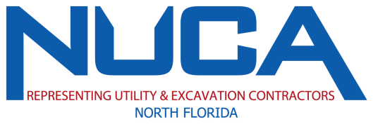
NUCANF Scholarship Eligibility Requirements

Who may apply for the J. Richard Baker Sr. Scholarship?
Any high school student or high school graduate who is the daughter or son of a NUCANF member company employee and will be enrolling full or part time in an academic institution of higher education or trade school (such as Welding, HVAC, Plumbing, Electrical, Mechanical etc.), beginning this summer or fall. Enrollment may be in any curriculum for any number of years. The J. Richard Baker Scholarship is a $3,000 one-time award.

How will the J. Richard Baker application be judged?
Selection will be based on the general worthiness of the application. The NUCANF Scholarship Committee will consider (1) scholastic standing, (2) ACT and/or SAT scores, (3) extracurricular activities, (4) career goals, (5) past employment, (6) essay and (7) thoroughness of the completed application. Once all applications for the J. Richard Baker scholarship are reviewed and a winner determined, the non-winning applicants will be considered for the Mike Allen Scholarship.

Who may apply for the Mike Allen Scholarship?
Any high school student, High School graduate, Undergraduate College Student or Graduate Student who is the daughter or son of a NUCANF member company employee or a member company employee and is enrolled or will be enrolling full or part time in an academic institution of higher education, beginning this summer/fall. Enrollment may be in any curriculum for any number of years. This may be a four-year college or a community college anywhere in the United States. The Mike Allen Scholarship is a $3,000 one-time award.

How will the Mike Allen application be judged?
Selection will be based on the general worthiness of the application. The NUCANF Scholarship Committee will consider (1) scholastic standing (2) extracurricular activities, (3) career goals, (4) past employment, (5) essay and (6) thoroughness of the completed application. Special consideration will be given to those pursuing degrees in construction related fields.

How do I apply?
Complete the application forms in accordance with the instructions and email to nucanf@gmail.com.

How will the confidentiality of the application be protected?
When the application has been received by NUCANF each application is given a number and an acknowledgement is sent to the applicant. The application is handled only by the Executive Director of the association. Once this has been done, the first page of the application will be placed in a sealed envelope marked only with the application number. The Executive Director then reviews the application in detail and removes any and all words or references that provide information relating to the applicant’s name, sex, race, religion, address or company. The Scholarship Committee will meet at predetermined times and review only sanitized copies of the application. Any committee member who recognizes the applicant through the remaining information will disqualify themselves from consideration of that application and the remaining committee members will make the determination. Only winning envelopes are opened, and the others are destroyed.

What must accompany the application?
See details on application.

When must I apply?
All applications must be received no later than May 15th. The award winner will be notified no later than June 30th.

How can I obtain further information?
If you have questions or need clarification or any details contact the Executive Director by telephone during business hours at (904) 612-8692 or at nucanf@gmail.com.

